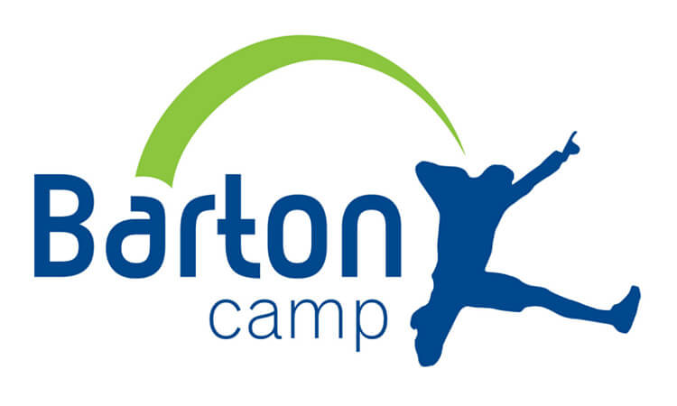

Bristol Junior Lawyers Division selects Bristol Children’s Help Society as Charity of the Year for 2023

Bristol Junior Lawyers Division (JLD) is proud to announce that it will be supporting Bristol Children’s Help Society (BCHS) as its Charity of the Year for 2023. BCHS is a non-profit organization that provides residential and outdoor learning experiences for children who have had limited life opportunities due to personal circumstances. The organisation aims to foster self-determination, resilience, and aspiration through a variety of team-building activities in a rural residential setting.
BCHS is the charity responsible for Barton Camp, a fully accessible residential centre in Winscome, North Somerset. They aim to provide subsidised camps to ensure that children with any form of disadvantage can experience outdoor adventure and enjoy a great time. In June 2020, BCHS received the Queen’s Award for Voluntary Service, which is the highest award a voluntary group can receive in the UK.
Tom Hood and Nigel Greenhalgh from BCHS recently met with the Bristol JLD Committee to discuss fundraising opportunities for the coming year. Tom Hood, President of the charity, expressed his delight at being chosen as Bristol JLD's Charity of the Year and looks forward to supporting Bristol JLD's fundraising events throughout the year.
As part of its support for BCHS, Bristol JLD will be undertaking a range of fundraising and awareness-building activities and events, including Pub Quizzes and its Annual Summer Ball, as well as forging closer links with the charity. The Bristol JLD Committee is also excited to visit Barton Camp.
Roisin O’Dubhlaoidh, Chairperson of Bristol JLD, commented:
“Bristol Children’s Help Society are responsible for providing disadvantaged children access to opportunities that those in our profession are generally very fortunate to have had ready access to growing up. This might be the opportunity to go on holiday with our siblings or friends or it may be something as simple as seeing a farm animal for the first time or learning how to use a barbeque or put up a tent.”
“We are delighted to able to support the mission of BCHS for 2023 and hope to be able to fund a residential placement for one of the many groups they support throughout the year.”
Bristol JLD selects a local charity every year, which becomes the focus of its fundraising efforts. Last year, the organization raised £3,892.00 for St. Mungo’s, a charity dedicated to ending homelessness and rebuilding lives. By partnering with BCHS, Bristol JLD hopes to make a meaningful contribution to the lives of children who have faced significant challenges and support a vital organization in its mission.
To visit Bristol Children’s Help Society, please click here: https://www.bartoncamp.org/

